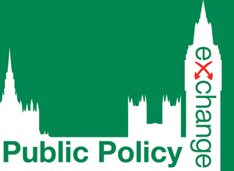 | The Future of Waste Management  Promoting a Circular Economy in the UK  14th March 2017

Delegate Fees
 | Central Government Departments  and Executive Agencies, NDPBs | Local Authorities, Police, Probation, Fire, NHS, Education, NGOs, National Charities, Housing Associations, Trade Unions, Think Tanks | Supported Rate for  Local Voluntary Groups
1 Place | STANDARD RATE: £395 | STANDARD RATE: £295 | STANDARD RATE: £195
2+ Places | STANDARD RATE: £345 | STANDARD RATE: £265 | STANDARD RATE: £175

1 Place | EARLY BOOKING RATE: £316 | EARLY BOOKING RATE: £236 | EARLY BOOKING RATE: £156
2+ Places | EARLY BOOKING RATE: £276 | EARLY BOOKING RATE: £212 | EARLY BOOKING RATE: £140
** Early Booking Discounted Rate Valid Until 3rd February 2017 **
Private Sector

Delegate Details
Delegate Name | Position | Email Address
1
2.
3.

* Please inform us in advance by email of any accessibility/dietary requirements.

Key Contact Details Invoice Details
Name:  Organisation:  Department:  Address:  Telephone:  Email:  Invoice details are the same as Key Contact Details | Name:  Organisation:  Department:  Address:  Telephone:  Email:  Purchase Order No. (if applicable):

Method of Payment
I will pay £ + VAT by GPC / Credit Card (Please contact me to obtain card details)
Please invoice my organisation for £ + VAT
I enclose a cheque for £ + VAT payable to Public Policy Exchange Ltd

Confirmation
I/We agree to notify you of all cancellations and changes in writing no less than 30 days prior to the date of the event. I/We further agree to pay £100 administration charge per place on cancellation. If cancellation is received less than 30 days prior to the date of the conference then the full fee is payable; however, a substitute may be sent.
Signed:
Date:

PLEASE EMAIL BACK TO bookings@publicpolicyexchange.co.uk

